**Mockito Hands-On Exercises**

**Exercise 1: Mocking and Stubbing**

Scenario: You need to test a service that depends on an external API. Use Mockito to mock the external API and stub its methods.

Steps:

1. Create a mock object for the external API.

2. Stub the methods to return predefined values.

3. Write a test case that uses the mock object.

**Answer:**

**ExternalAp.java**

package com.example;

public interface ExternalApi {

String getData();

}

**MyService.java**

package com.example;

public class MyService {

private ExternalApi api;

public MyService(ExternalApi api) {

this.api = api;

}

public String fetchData() {

return api.getData();

}

}

**MyServiceTest.java**

package com.example;

import org.junit.jupiter.api.Test;

import static org.junit.jupiter.api.Assertions.assertEquals;

import static org.mockito.Mockito.*;

public class MyServiceTest {

@Test

public void testExternalApi() {

// ✅ Step 1: Create mock

ExternalApi mockApi = mock(ExternalApi.class);

// ✅ Step 2: Stub method

when(mockApi.getData()).thenReturn("Mock Data");

// ✅ Step 3: Inject mock into service

MyService service = new MyService(mockApi);

// ✅ Step 4: Call method and assert result

String result = service.fetchData();

assertEquals("Mock Data", result);

}

}

**pom.xml**

<?xml version="1.0" encoding="UTF-8"?>

<project xmlns="http://maven.apache.org/POM/4.0.0"

xmlns:xsi="http://www.w3.org/2001/XMLSchema-instance"

xsi:schemaLocation="http://maven.apache.org/POM/4.0.0 http://maven.apache.org/xsd/maven-4.0.0.xsd">

<modelVersion>4.0.0</modelVersion>

<groupId>org.example</groupId>

<artifactId>Mocking_and_Stubbing</artifactId>

<version>1.0-SNAPSHOT</version>

<properties>

<maven.compiler.source>21</maven.compiler.source>

<maven.compiler.target>21</maven.compiler.target>

<project.build.sourceEncoding>UTF-8</project.build.sourceEncoding>

</properties>

<dependencies>

<!-- JUnit 5 -->

<dependency>

<groupId>org.junit.jupiter</groupId>

<artifactId>junit-jupiter</artifactId>

<version>5.10.0</version>

<scope>test</scope>

</dependency>

<!-- Mockito -->

<dependency>

<groupId>org.mockito</groupId>

<artifactId>mockito-core</artifactId>

<version>5.11.0</version>

<scope>test</scope>

</dependency>

</dependencies>

</project>

**Output:**

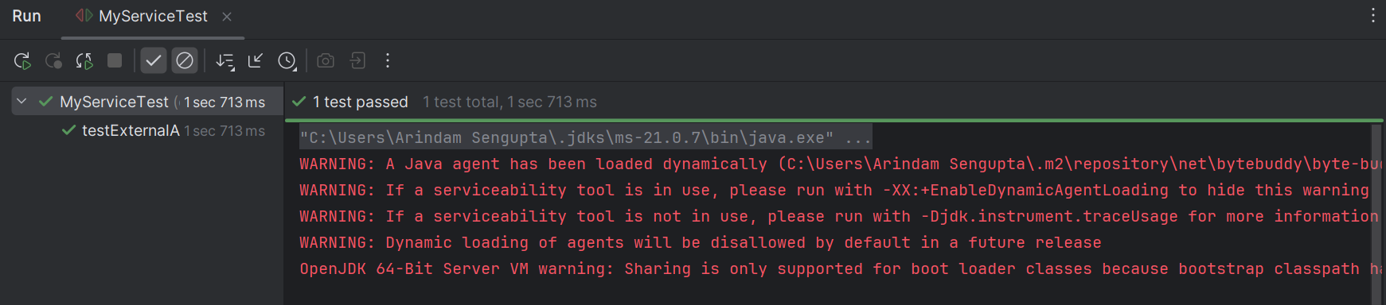

**Exercise 2: Verifying Interactions**

**Scenario:** You need to ensure that a method is called with specific arguments.

Steps:

1. Create a mock object.

2. Call the method with specific arguments.

3. Verify the interaction.

**Answer:**

**ExternalAp.java**

package com.example;

public interface ExternalApi {

String getData();

}

**MyService.java**

package com.example;

public class MyService {

private ExternalApi api;

public MyService(ExternalApi api) {

this.api = api;

}

public String fetchData() {

return api.getData();

}

}

**MyServiceTest.java**

package com.example;

import org.junit.jupiter.api.Test;

import static org.mockito.Mockito.*;

public class MyServiceTest {

@Test

public void testVerifyInteraction() {

// Step 1: Mock ExternalApi

ExternalApi mockApi = mock(ExternalApi.class);

// Step 2: Inject mock into MyService

MyService service = new MyService(mockApi);

// Step 3: Call method

service.fetchData();

// Step 4: Verify method call

verify(mockApi).getData();

}

}

**Output:**

